
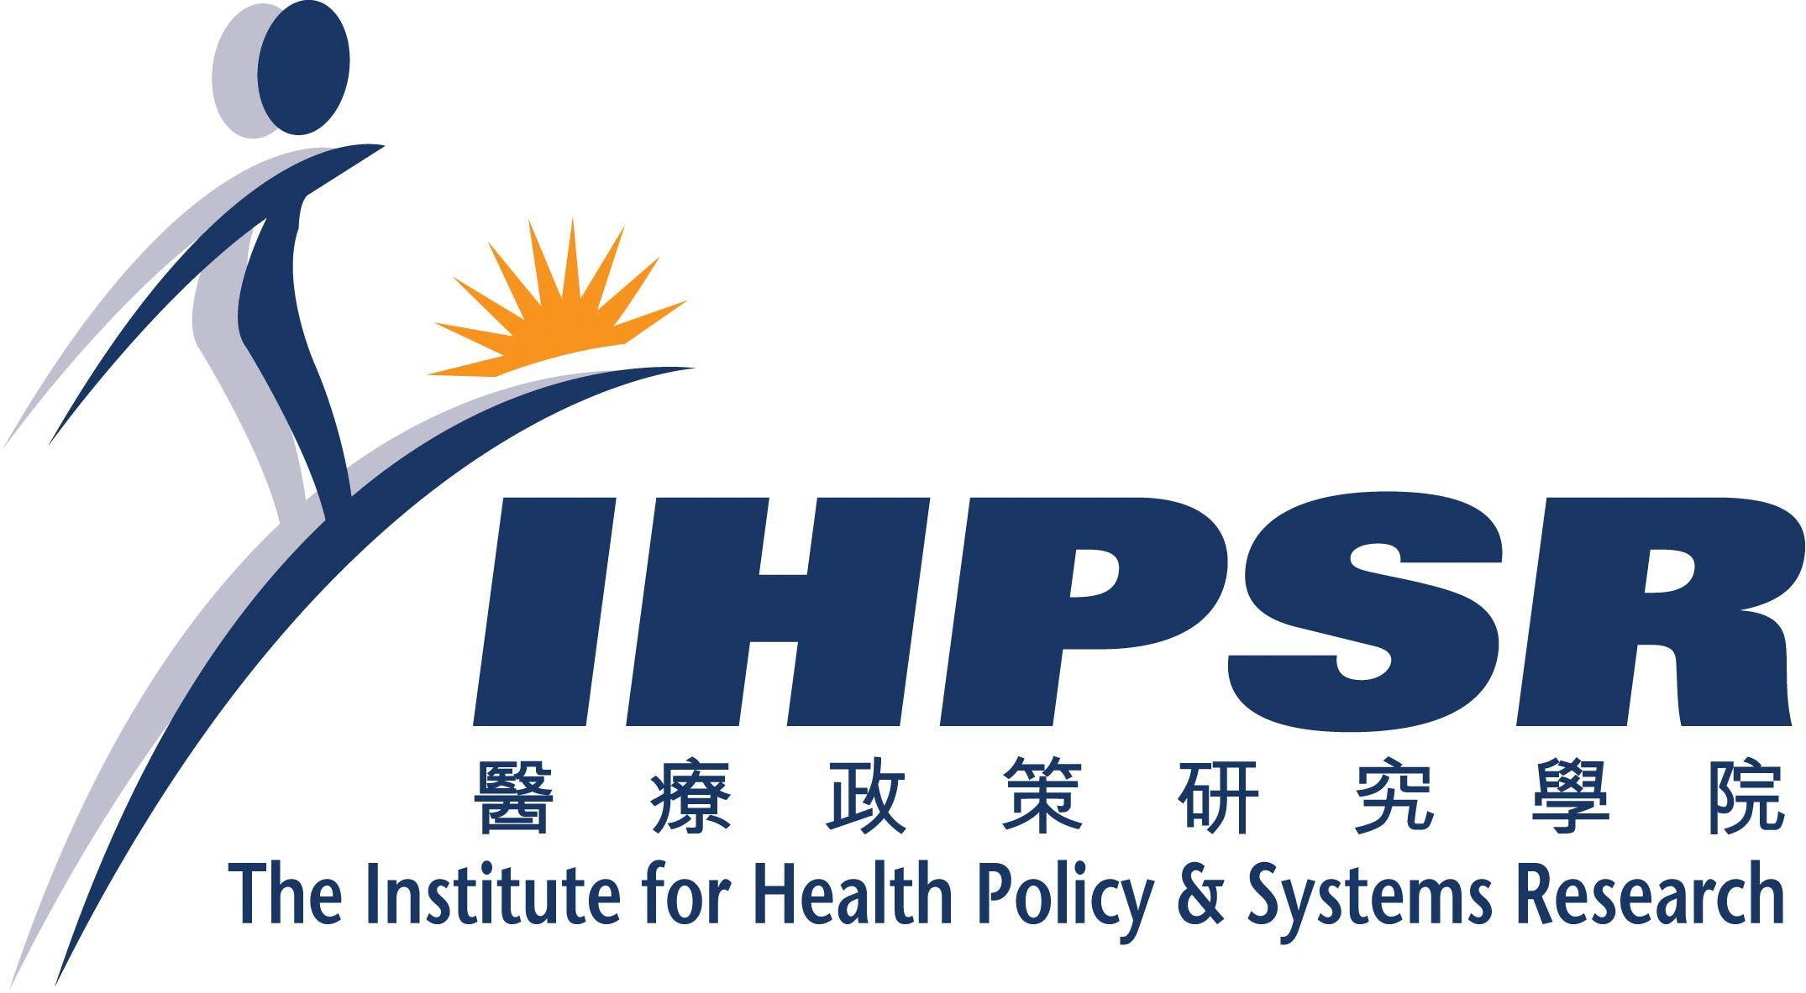


Forum on Current Bioethical Issues (4)

Obstetric Service for Mainland Pregnant Mother in Hong Kong

In order to arouse pubic awareness and ethical discussion on the above controversial subject in Hong Kong, the Hong Kong Bioethics Association, the Institute for Health Policy and Systems Research and the Medical Ethics Unit of LKS Faculty of Medicine of the University of Hong Kong have jointly organized an open forum in early February 2007. The details of the meeting are as follows:

Date: 2nd February 2007 ( Friday)
Time: 7.30 pm - 9.30 pm

Venue: Seminar Room, Info World, Hospital Authority Head office Argyle Street Kowloon

Moderator:
Mr. Ng Ming Lam

Panel Discussants:
Dr. Vivian Taam Wong
Director(Strategy & Planning) Hong Kong Hospital Authority
Dr. Leung Kwok-Ling Ares
Deputy Medical Director and Private Obstetrician, Union Hospital
Mr. Ho Hei Wah
Director, Society for Community Organization
Mr. Lau Chun To
Lawyer and Editorial Writer, Mingpao

We would be most grateful if you can display the enclosed flyer in your Institute and encourage your colleague to attend this worthwhile function. Please do not hesitate to contact Mr Kevin Chung at email kchung@ihpsr.org or Tel 2836 3760 if you have any enquiries.

Thank you very much for your kind attention!

REPLY FORM

TO: The Institute for Health Policy and Systems Research

I will / will not* attend the following forum between 7.30pm -9.30 pm. on Friday 2nd February 2007

Forum on Obstetrics Service for Mainland Pregnant Mother in Hong Kong

Number of participants:

*Please delete as appropriate and complete the information below.
Name:

Position:

Name of Organization:

Email address:

Telephone Number:

Please fax the reply form with the attention of Mr Kevin Chung at 81473120. For enquiries, please call Mr Chung at 2836 3760.

Acknowledgement

The Organizing Committee is indebted to the following Institutes/Organizations for sponsoring and supporting this event:

A World Consulting
Canossa Hospital
Caritas Medical Centre
Chinese YMCA of Hong Kong
Cypress Finance Company
Department of Social Work, Hong Kong Baptist University
Health Express
Hercules Medical Diagnostics and Laboratory Group
Holy Spirit Seminary College
Hong Kong Bioethics Association
Hong Kong Civic Association
Hong Kong Down Syndrome Association
Hong Kong Hospital Authority
Hong Kong Medical Association
Hong Kong Society of Medical Genetics
Matilda International Hospital
Medical Ethics Unit, Li Ka Shing Faculty of Medicine, University of Hong Kong
Our Lady of Maryknoll Hospital
St. Paul’s Hospital
Talentum Bookshop and Living Faith Spiritual Centre
The Institute of Health Policy and System Research
Union Hospital
Veritas Medical Practice

