
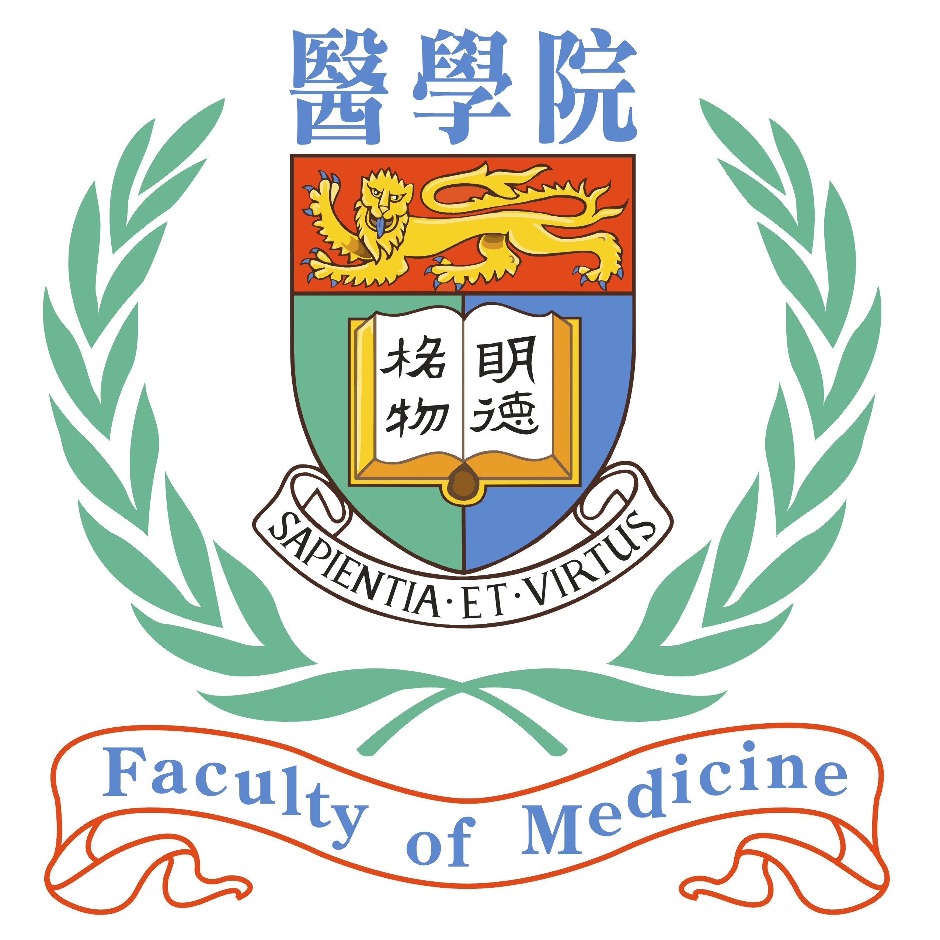

Medical Ethics Unit Hong Kong Bioethics Association
Li Ka Shing Faculty of Medicine
University of Hong Kong

10th July 2006

Dear Sir/Madam,

Ref: Forum on Prenatal Diagnosis on 28th July 2006 (Friday)

In order to arouse pubic awareness and discussion on current bioethical issues in Hong Kong, the Medical Ethics Unit of Li Ka Shing Faculty of Medicine of the University of Hong Kong and the Hong Kong Bioethics Association will organize a series of Open Forums from late July to November this year. The detail of the first Open Forum on Ethical Issues in Prenatal Diagnosis is as follows:

Date: 28th July 2006 (Friday)
Time: 7.00 pm – 10.00 pm.
Venue: Function Room, 1/F, Eaton Hotel, Nathan Road, Jordan, Kowloon.
Registration Fee (including Dinner): $300
(NB. Special Discount Rate of $250 for members of Medical Ethics Unit, Li Ka Shing Faculty of Medicine HKU and Hong Kong Bioethics Association)

Deadline for Registration: 21st July 2006 (Friday)

We would be most grateful if you can display the enclosed flyers in your Institute and encourage your staff/members to attend this worthwhile function. Please do not hesitate to contact Ms. Fancy Choi, social worker of the Hong Kong Down Syndrome Association, at 2718 7777 (e-mail: fancy@hk-dsa.org.hk) if you have any enquries.

Thank you for your kind attention.

Yours sincerely,

Professor Edwin Hui Dr. Robert Yuen
Director Private Practice Paediatrician
Medical Ethics Unit Chairman
Li Ka Shing Faculty of Medicine Hong Kong Bioethics Association
University of Hong Kong

The Organizing Committee is indebted to the following Institutes/Organizations for sponsoring and supporting this event:

A World Consulting
Canossa Hospital
Caritas Medical Centre
Chinese YMCA of Hong Kong
Cypress International Investment Advisors Limited
Department of Social Work, Hong Kong Baptist University
Health Express
Hercules Medical Diagnostics and Laboratory Group
Holy Spirit Seminary College
Hong Kong Bioethics Association
Hong Kong Civic Association
Hong Kong Down Syndrome Association
Hong Kong Hospital Authority
Hong Kong Medical Association
Hong Kong Society of Medical Genetics
Matilda International Hospital
Medical Ethics Unit, Li Ka Shing Faculty of Medicine, University of Hong Kong
Our Lady of Maryknoll Hospital
St. Paul’s Hospital
Talentum Bookshop and Living Faith Spiritual Centre
The Institute for Health Policy and Systems Research
Union Hospital
Veritas Medical Practice

Medical Ethics Unit Hong Kong Bioethics Association
Li Ka Shing Faculty of Medicine
University of Hong Kong

Open Forum on Current Bioethical Issues (1)
Ethical Issues in Prenatal Diagnosis

Date : 28th July 2006 (Friday)
Time: 7.00 pm. – 10.00 pm.
Venue: Function Room 1/F Eaton Hotel, 380 Nathan Road, Jordan, Kowloon.
Registration Fee (including Dinner): $300
(NB. Special Discount Rate of $250 for members of Medical Ethics Unit, Li Ka Shing Faculty of Medicine HKU and Hong Kong Bioethics Association)

Programme:
7.00 p.m. – 7.30 p.m. Reception

7.30 p.m. – 8.15 p.m. Speakers’ Forum
- Introductory Remarks and Report on the Working Group of Prenatal Diagnosis 2005-06
Dr. Robert Yuen, Private Practice Paediatrician, Chairman, Hong Kong Bioethics Association
- Ethics of Prenatal Diagnosis
Professor Edwin Hui, Director, Medical Ethics Unit, Li Ka Shing Faculty of Medicine, University of Hong Kong
- Ethical Issues of Surgery in the Prenatal Period
Professor C.K. Yeung, Professor of Surgery, Department of Surgery, Chinese University of Hong Kong
- Opinion Survey on Prenatal Diagnosis in Hong Kong
Professor Mark Li, Assistant Professor, Department of Social Work, Hong Kong Baptist University

8.15 p.m – 10.00 p.m. Dinner and Open Forum

Please register via email: fancy@hk-dsa.org.hk or fill in the reply slip by fax (2718 0811) on or before 21st July 2006 and send the cheque payable to ‘Hong Kong Bioethics Association’ to the following address: Hong Kong Down Syndrome Association, G/F., Wing A, Chun Tung House, Tung Tau Estate, Kowloon. All enquiries should be directed to Ms. Fancy Choi at 2718 7777 (During Office Hours on weekdays except Monday).
To: Hong Kong Bioethics Association
c/oHong Kong Down Syndrome Association

Fax: 2718 0811 Tel: 2718 7777

Open Forum on Current Bioethical Issues (1)
Ethical Issues in Prenatal Diagnosis

Date : 28th July 2006 (Friday)
Time: 7.00 pm. – 10.00 pm.
Venue: Function Room 1/F Eaton Hotel, 380 Nathan Road, Jordan, Kowloon.
Registration Fee (including Dinner): $300
(NB. Special Discount Rate of $250 for members of Medical Ethics Unit, Li Ka Shing Faculty of Medicine HKU and Hong Kong Bioethics Association)

Reply Slip

Please put a tick (✓) in an appropriate box.

- I will attend the open forum. A cheque in the amount _____________ is enclosed/will be sent to Ms. Fancy Choi at The Hong Kong Down Syndrome Association.

- I will not be able to attend the open forum, but I will send a representative ____________________________ (Name of representative) to attend on my behalf.

- Sorry, I will not be able to attend the open forum.

Name: ___________________________ Designation: ______________________

Name of Organization/Agency: _______________________________________________

Telephone No: ______________________ Fax No:______________________________

Correspondence/Address: ____________________________________________________

E-mail Address: ____________________________ Date: ________________________

